Construction of a Spatial Depopulation Risk Index for municipalities of Castilla-La Mancha

HIDALGO ARELLANO, ISIDRO; FERNÁNDEZ-AVILÉS CALDERÓN, GEMA

Universidad de Castilla-La Mancha

Isidro.Hidalgo@uclm.es

Depopulation has become a significant problem in Castilla-La Mancha: vast areas of Cuenca and Guadalajara have a lower population density than Siberia. Different national governments and regional authorities have developed classifications of the depopulation risk facing villages and towns. For example, the Government of Castilla-La Mancha uses descriptive statistics, taking into account social and economic variables to classify areas on a range from “urban” to “zones with extreme risk of depopulation”.

The main aim of this work is the construction of a Spatial Depopulation Risk Index for the 919 municipalities of Castilla-La Mancha, using geostatistical techniques and principal component analysis. The theoretical semivariogram reveals spatial dependence up to a distance of 60 kilometers. Based on the range of spatial dependence, a neighborhood network is constructed. Then a spatial principal component analysis (sPCA) [1] is applied to a set of demographic variables. Finally, the spatial depopulation risk index (sDRI) is designed by extracting and scaling the first principal component of the sPCA.

As can be seen from the figure below, the resulting sDRI identifies numerous areas as having a medium to high risk of depopulation; namely, the majority of villages of Cuenca and Guadalajara, and the west and the south of the region. Conversely, it shows no risk for the areas of La Mancha and the Sagra and Henares industrial corridors, as well as the provincial capitals, Talavera de la Reina and Puertollano.

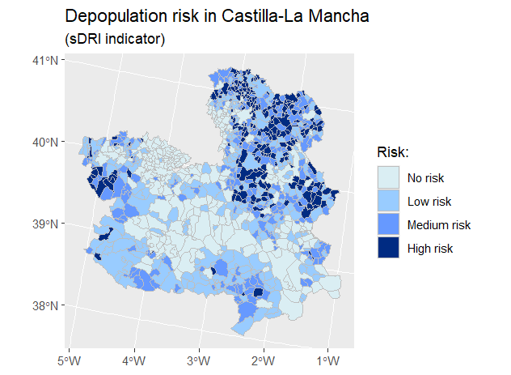

References

1. Jombart, T.; Devillard, S.; Dufour, A.-B.; Pontier, D. *Revealing cryptic spatial patterns in genetic variability by a new multivariate method*, Heredity, 101 (2008), 92-103.